Installations & Deployment
- Overview
This document explains how to setup AWS to allow running:
- Server
- process-eng-app

Afterwards also run
- OperatorApp
connected to the server running at AWS.
In AWS using :
- EC2 instance (to run server & process-eng-app),
- Nginx on EC2 instance to provide a bridge for process-eng-app static files,
- Google Sheets (to be replaced by SQL),
- MongoDB on EC2 instance,
- AWS S3 to store test application executable files,
- AWS S3 to store reports.
- AWS S3 (for new AWS only)
AWS S3 is a AWS storage that will store files (zips for the test applications and pdfs for test reports).
- Open AWS Console:
https://us-east-2.console.aws.amazon.com/console/home?region=us-east-2
Use root user to enter.
- Type “S3” at the search bar at the top.
Enter S3 Dashboard.
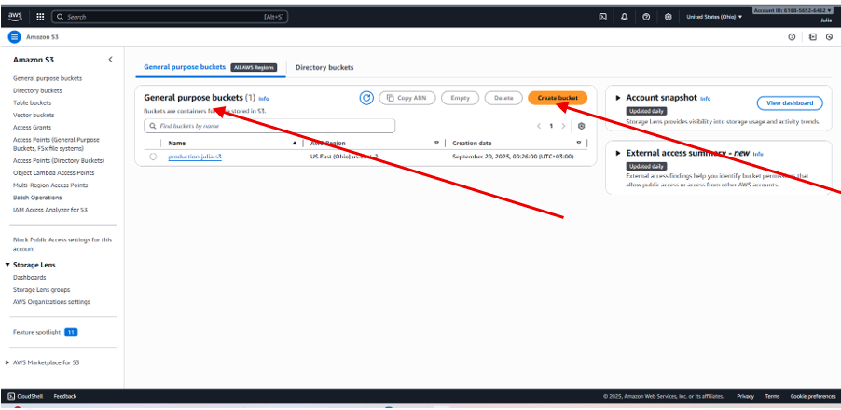
- This step is one-time action, only if the AWS S3 is created from scratch:
  - General purpose bucket
Create General purpose bucket.
- The name shall be unique across any general purpose bucket at the whole AWS.
- If the name of the bucket will differ from “production-julia-s3”, code of the server shall be changed, since this name is hardcoded.
Try to use the same name.
- During bucket creation use all default settings.
  - Permissions for “production-julia-s3”
In order to allow uploading files to the bucket from different IPs, special permissions shall be set.
- Enter “Permissions” tab:
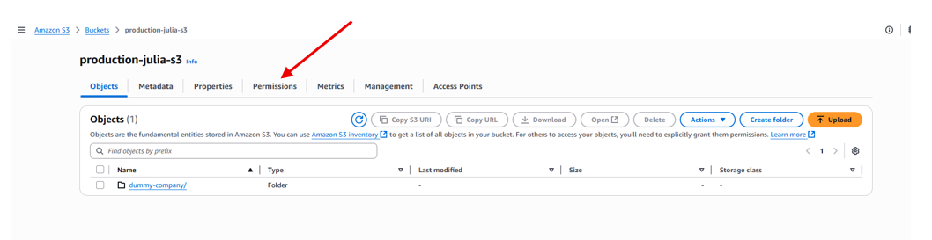
- Scroll down to the “Cross-origin resource sharing” (CORS)
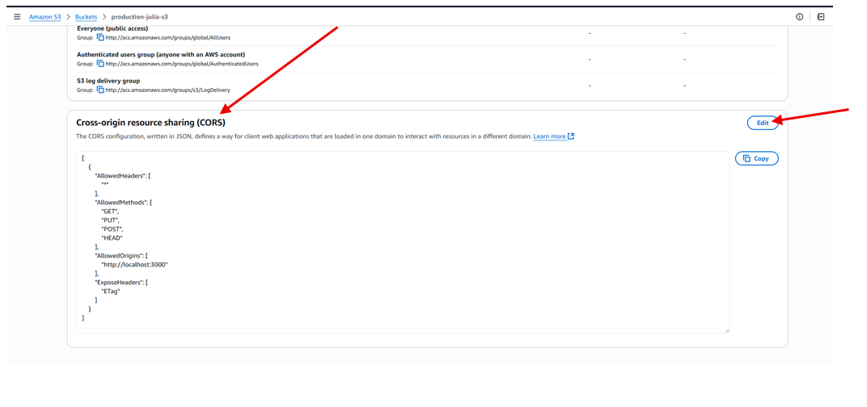
- Press Edit.

For only development work insert:
[
{
"AllowedHeaders": [
"*"
],
"AllowedMethods": [
"GET",
"PUT",
"POST",
"HEAD"
],
"AllowedOrigins": [
"http://localhost:3000"
],
"ExposeHeaders": [
"ETag"
]
}
]
For production add TBD

- Only 1st time - Configure AWS EC2
  - Create AWS EC2 instance
AWS EC2 runs server and stores process-eng-app static html files.
- Open AWS Console:
https://us-east-2.console.aws.amazon.com/console/home?region=us-east-2
Use root user to enter.
- Type “EC2” at the search bar at the top.
Enter EC2 Dashboard.
- At the left bar click “Instances”->”Launch Instances” (button).
Type name (CalibrixEC2) and choose “Ubuntu”.

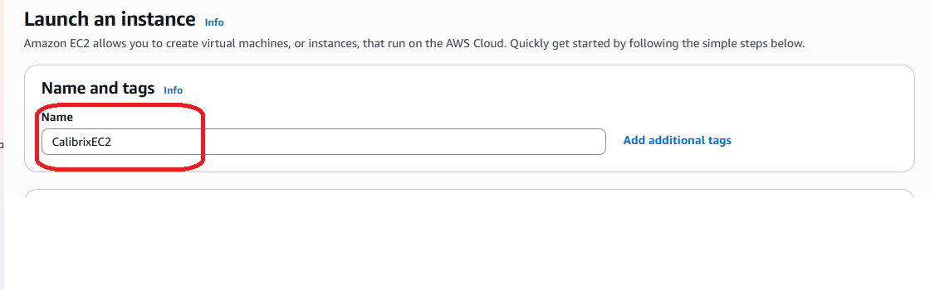
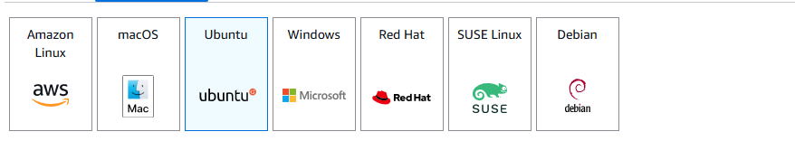
- Choose t3.small.
Create new key pair (save downloaded file).
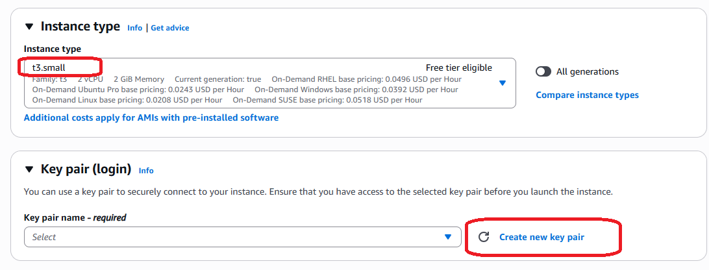

- At the “Network settings” section check the “Allow HTTP traffic from the internet”.
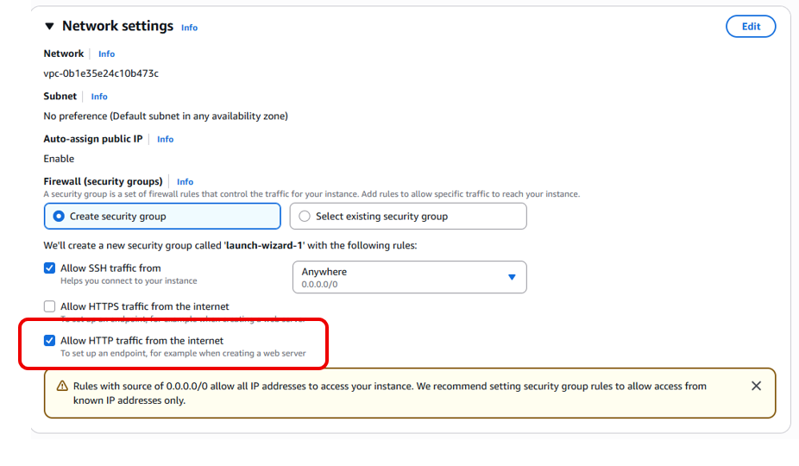

- Click “Launch instance”.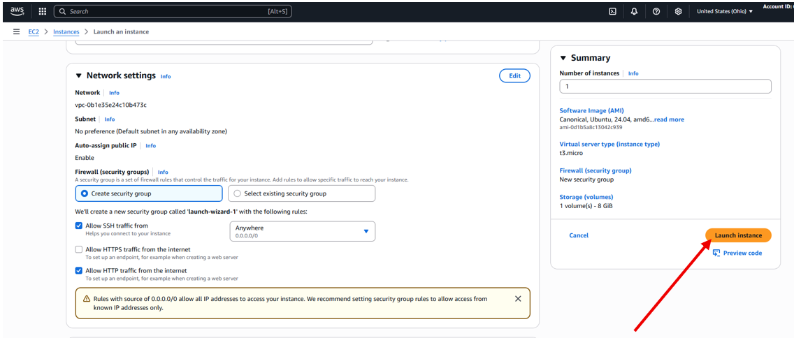
- Allocate “Elastic IP” and associate it to new instance.
Click “Elastic Ips” at the left bar:
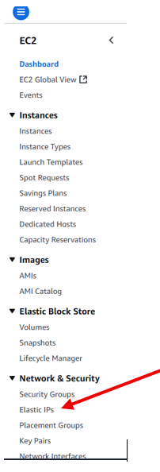
Allocate Elastic IP Address:
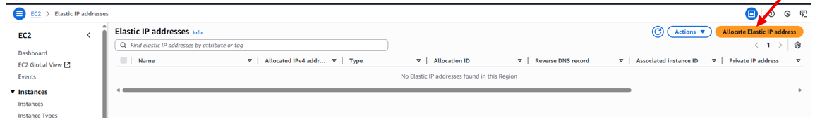
Check the Elastic IP just created and click “Associate Elastic IP address” at the “Actions” menu.
Choose both name and private IP of the instance just created.

- Go to “Instances”, check the just created instance and check that it has an Elastic IP” (scroll to the right).
- With the checked instance click “Connect”.
New tab is open with the ubuntu cmd window. At the cmd wnd do:
  - Install server & process-eng-app on EC2 instance
nano clone-git-repo.sh
<Paste contents of clone-git-repo.sh (at source control, ‘Scripts’ folder)>
bash clone-git-repo.sh https://github.com/JuliaF929/ProductionRepo.git CalibrixEC2
cd /opt/CalibrixEC2/ (here the source code was downloaded, if you change git folder, fix this name)
cd server
nano .env
Update CALIBRIX_SERVER_VERSION value according to GitHub tag# if required (the patch part of it)
<Save and exit>
cd dal/sheets/ (will enter server/dal/sheets/ since we already at the server folder)
nano productionapp-463314-77556795ce19.json
<Paste the contents of the secret file productionapp-463314-77556795ce19.json>
<Save and exit>
cd ../../../Scripts/
bash install-mongo.sh
bash linux-server-ec2-establish.sh
sudo systemctl daemon-reload
sudo systemctl restart ProductionServer.service #restart the server
sudo systemctl status ProductionServer.service --no-pager #validation that the server is running
bash linux-process-eng-app-ec2-after-server-establish.sh "<put here the Elastic IP allocated>" CalibrixEC2 process-eng-app 5000

Open browser with:
http://<Elastic IP>
and enjoy playing

  - Manual MongoDB configuration
Open MongoDB port in AWS Security Group (in order to enable connection from mongo Compass at local PC)
Go to the AWS Management Console.
Navigate to EC2 → Instances.
Select your instance (CalibrixEC2).

At the below part click “Networking” tab:
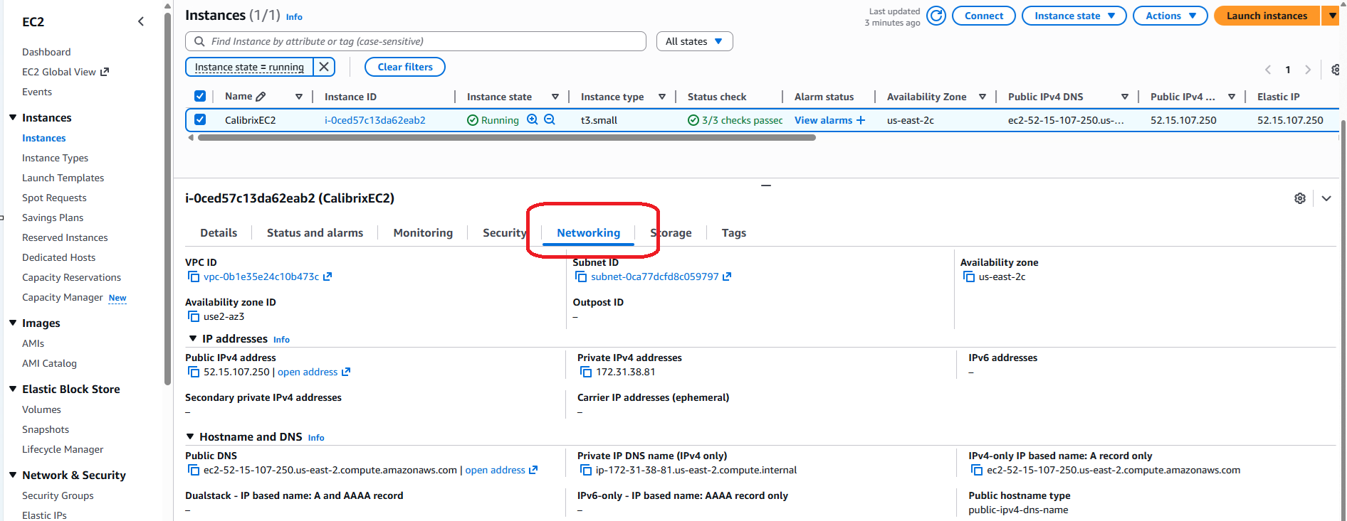

Scroll down, until you see:
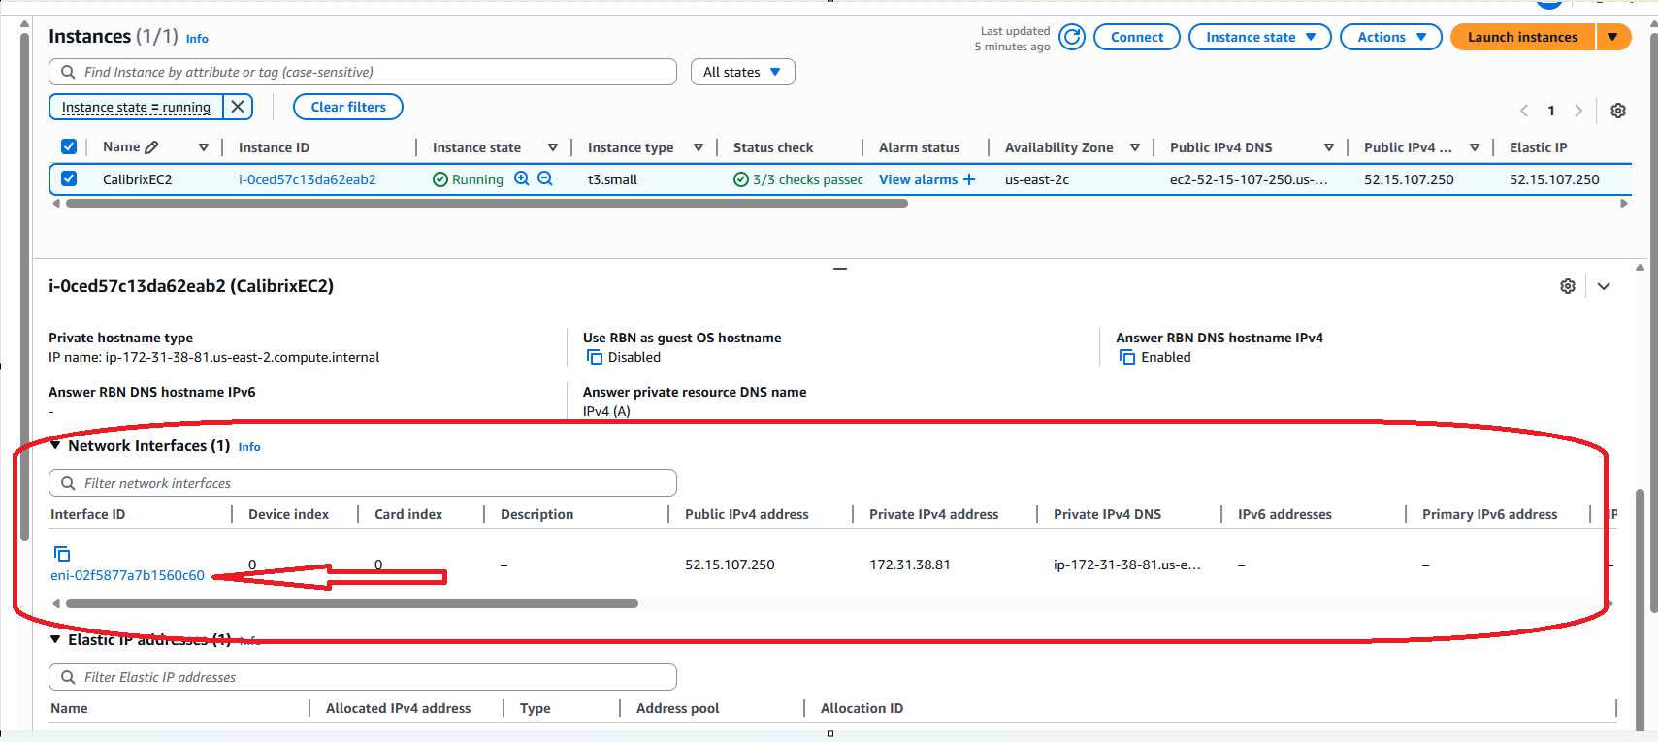

Click the link.
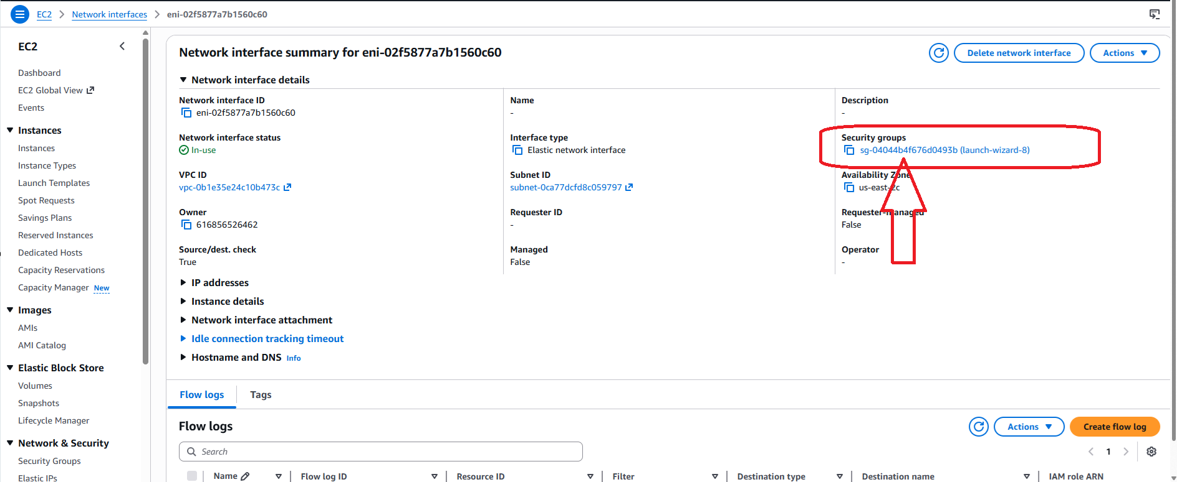
Click the link under “Security groups” section.
Inside the Security Group, go to the Inbound rules.
Click Edit inbound rules → Add rule:
- Type: Custom TCP
- Port range: 27017
- Source:
  - For testing, you can choose Anywhere (0.0.0.0/0) → but this is insecure ⚠️.
  - For safety, choose My IP → this will only allow your Windows PC’s public IP.
Save the rule.
MongoDB Compass at local PC
Add new connection->Change local host to the elastic IP->Connect
Compass connects successfully.
  - Give EC2 instance permission to upload files to S3 bucket
EC2 instance has to have AWS credentials available at runtime.
- An IAM Role is a permission profile
- You attach it to an EC2 instance
- AWS then injects temporary credentials automatically
- Your app uses them without config
No keys. No .env. No secrets. No GitHub violations.
To give credentials, follow the steps below:
- Top search bar → type IAM
- Left menu → click Roles
- Click Create role
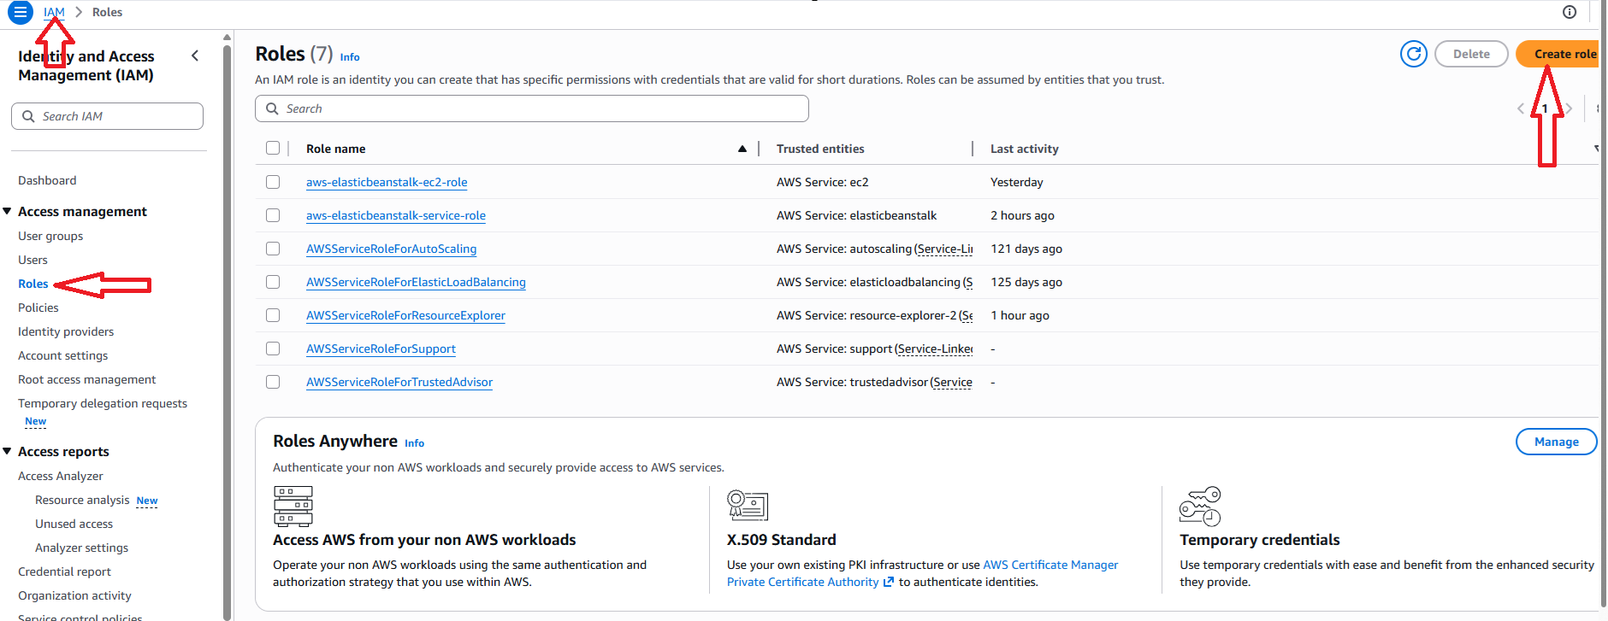

- “Trusted entity type”->AWS service
- Use case: Service or use case : choose EC2
- Next
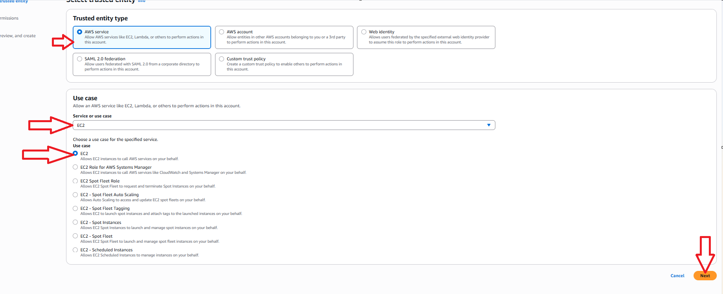
- On another browser tab at its address line type
https://console.aws.amazon.com/iam/home#/policies/create

- On the opened “Create Policy” page:

  - Click JSON
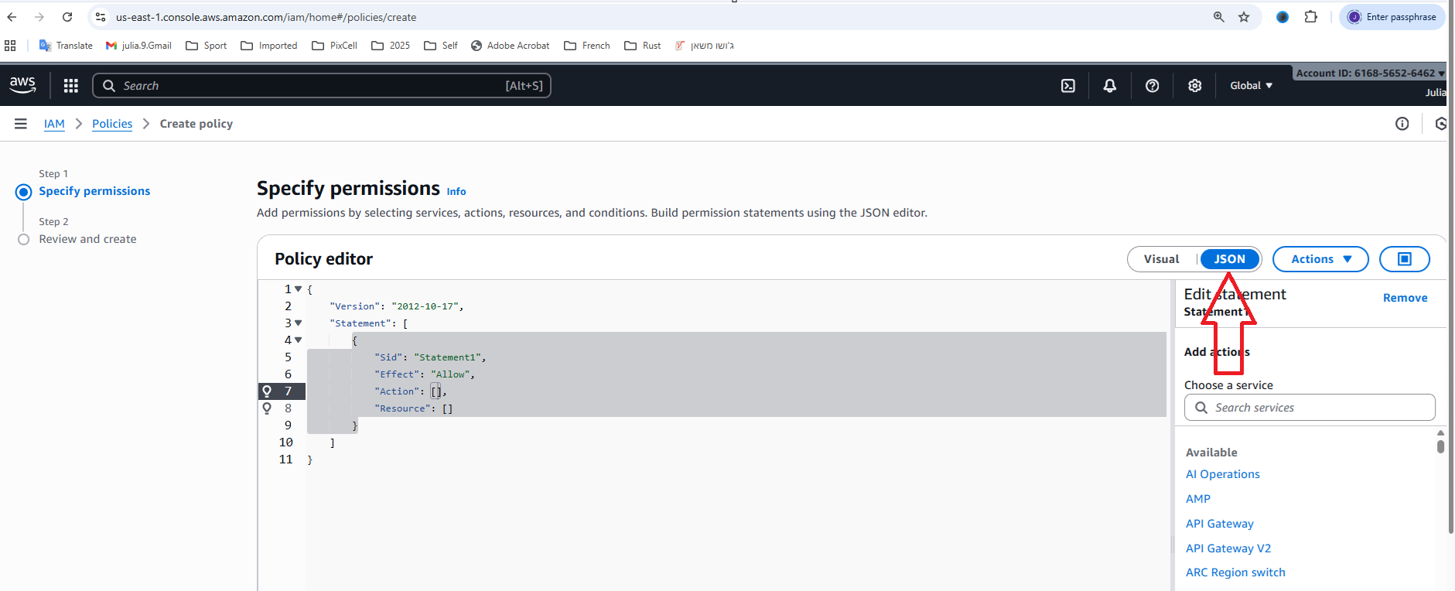
- Paste this code in “Policy editor”->Next:
{
"Version": "2012-10-17",
"Statement": [
{
"Effect": "Allow",
"Action": [
"s3:PutObject",
"s3:GetObject"
],
"Resource": "arn:aws:s3:::production-julia-s3/*"
}
]
}
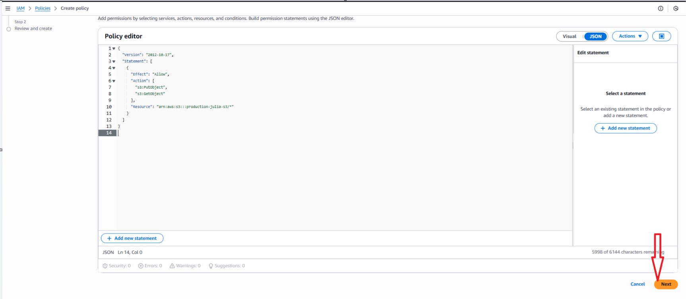
- Give policy name “EC2-Calibrix-S3Access” ->Create Policy:
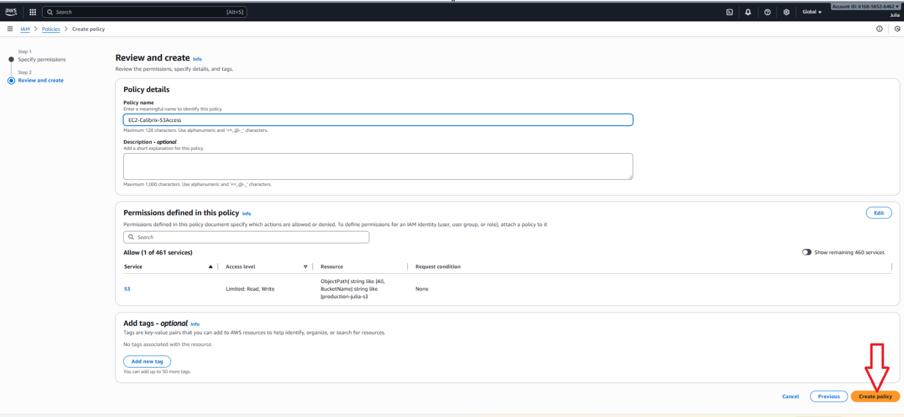
- Close the policy tab

- Back in the Create role screen (Refresh page):
- Search for “EC2-Calibrix-S3Access”, check it->Next
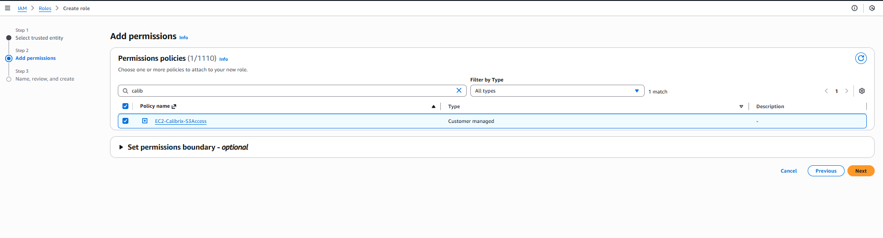
- Give name to new role: “CalibrixEC2-S3Role”->Create Role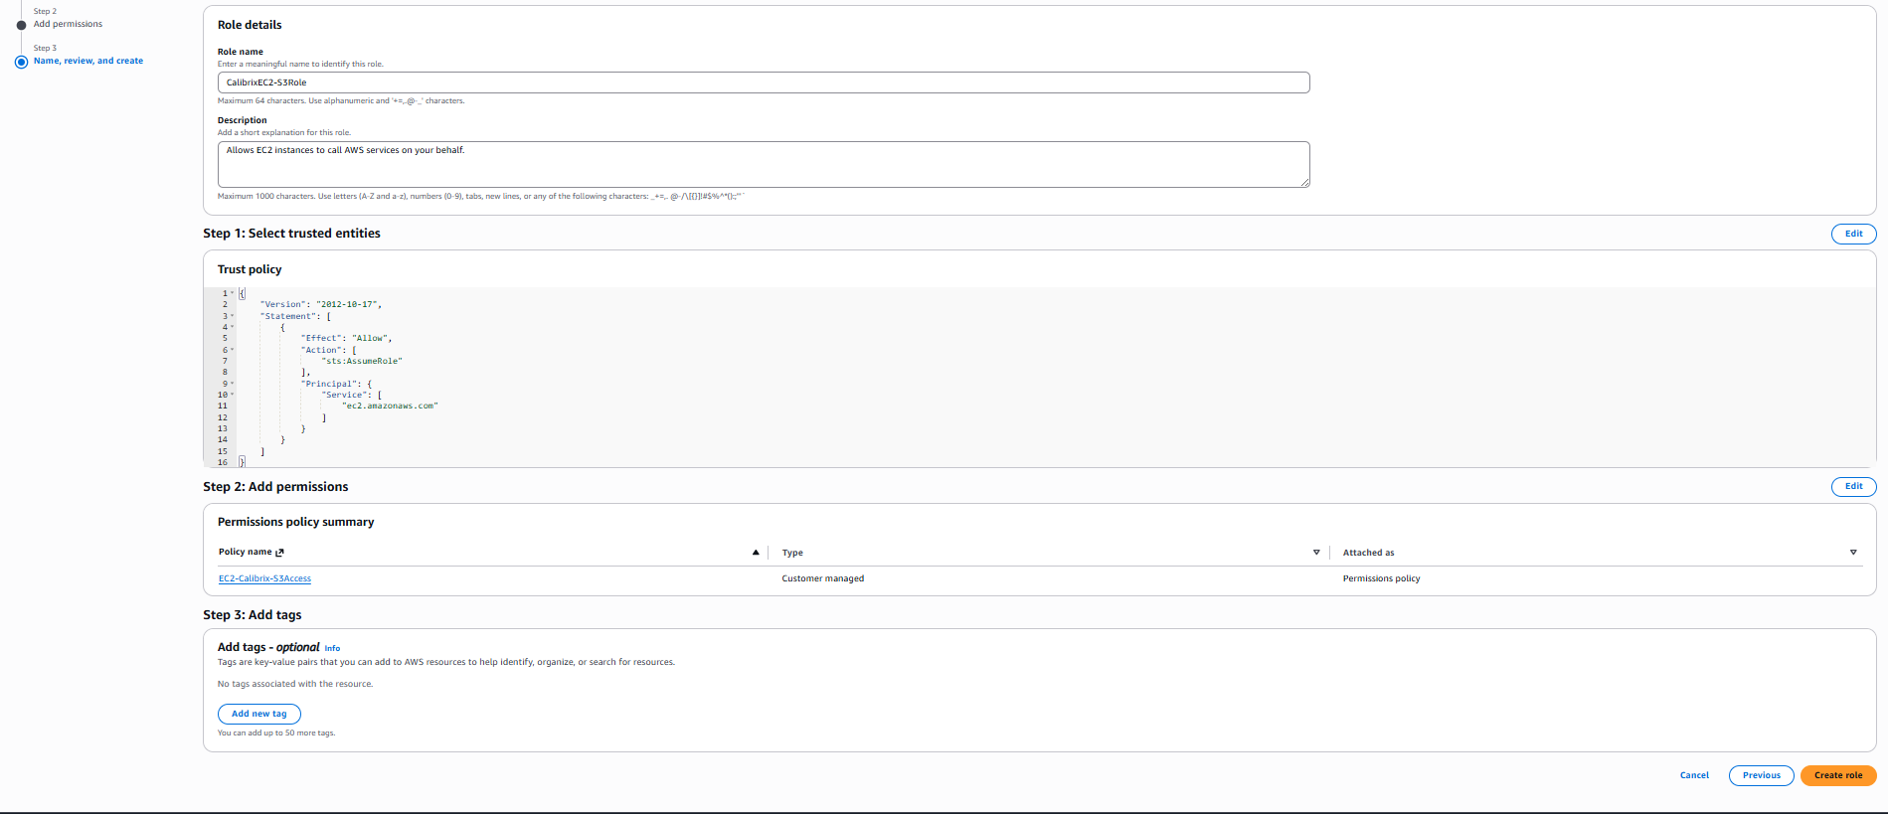
- Role is now created
❌ But NOT active yet.

- Attach role to EC2
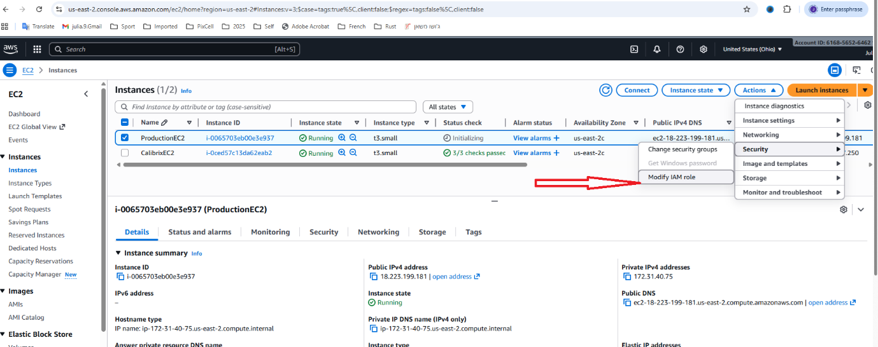
- Select EC2 instance and click Actions->Security->Modify IAM role:

- In a drop down select a just created role->Update IAM Role

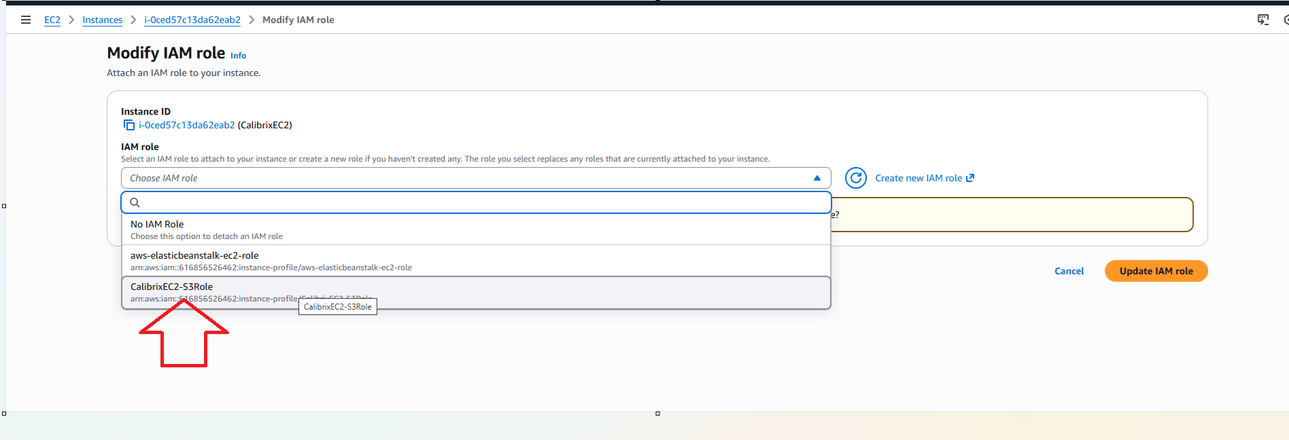

- Local Windows setups
  - MongoDB install replica set
Installing replica set is required to support transactions (save also itemAction to itemActionsHistory collection and updating item’s parameters in items collection).
MongoDB on Windows supports multi-document ACID transactions.
- Open cmd as administrator.
- Run:
net stop MongoDB
- Open Notepad as administrator, open mongod.cfg in it:
C:\Program Files\MongoDB\Server\<version>\bin\mongod.cfg
- Add under ‘#replication’:
replication:
replSetName: "rs0"
- Run:
net start MongoDB
- Install mongosh if not installed from:
https://www.mongodb.com/try/download/shell
Choose msi, not zip.
- Run:
mongosh
- Inside mongo shell:
rs.initiate()
- Verify it worked:
rs.status()
See:
...
set: ‘rs0’
...
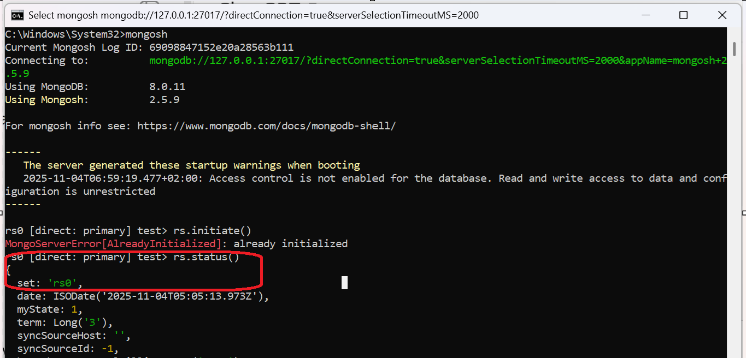

- Interesting issues faced
  - GitHub
Description:
Second workflow (yml) that shall run on a git push does not run.
Specifically, the yml that shall be triggered by a github tag creation and build the static files for process-eng-app (github artifacts) does not run.
Solution:
This is the security limitation where a GitHub Actions workflow triggered by the default bot token cannot trigger a subsequent workflow.
To fix this issue exactly and get your second workflow to run, you need to use a Personal Access Token (PAT) with specific permissions in the first workflow that creates the tag.
At GitHub account:
- Go to Developer settings > Personal access tokens.
- Select the Tokens (classic) tab (not the "Fine-grained tokens" tab).
- When generating a classic token, select the broad repo scope, which includes all the necessary permissions for pushing tags.
- Copy the token immediately (you will not see it again).
Add the Token as a Repository Secret:
- In your GitHub repository, navigate to Settings.
- In the left sidebar, select Secrets and variables, then click on Actions.
- Click the New repository secret button.
- For the Name, type PAT_FOR_WORKFLOW (using this exact name is important for the next step).
- For the Value, paste the token string you just copied.
- Click Add secret.
Update Your First Workflow (YAML File)
- Locate the step that uses actions/checkout@vX and add the token: parameter.
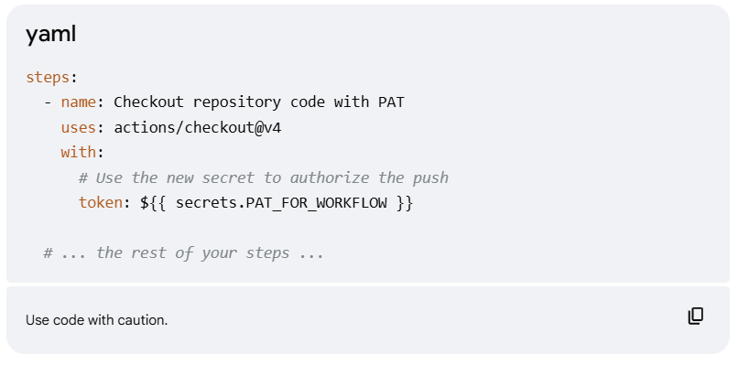

  - GitHub artifacts/releases
https://github.com/JuliaF929/ProductionRepo/releases/latest/download/process-eng-app-build.zip
This URL ALWAYS gives you the latest release ZIP.
Download in ubuntu from github:
wget -O process-eng-app-build.zip https://github.com/JuliaF929/ProductionRepo/releases/latest/download/process-eng-app-build.zip
sudo unzip process-eng-app-build.zip
rm process-eng-app-build.zip
sudo mv build/* .
sudo rm -rf build/

- Deploy of new version
The following updates both server and process-eng-app.
  - Update ver#
If MAJOR or MINOR shall be updated:
- cd Scripts/
- node .\update_major_minor_version.js <major.minor>
- Commit & push changes.
  - Deploy
cd /opt/CalibrixEC2/Scripts/
bash deploy-calibrix.sh CalibrixEC2 <new version#> ProductionServer
- CalibrixEC2 – EC2 instance name
- ProductionServer – server name
Some interesting thing:
